CHAPTER 5
PROBABILITY: REVIEW OF BASIC CONCEPTS

SECTION EXERCISES
5.1 d/p/m This is a subjective probability, since it represents the degree to which the president believes that an event will occur.

5.2 d/p/m The sample space consists of two possible outcomes: (1) Air France begins making daily flights to Pocatello, Idaho, and (2) it does not. The possible events that could occur are:
A = Air France begins making daily flights to Pocatello, Idaho, and
A' = Air France does not begin making daily flights to Pocatello, Idaho
P(A) is approximately zero, therefore P(A') is approximately 1 – 0 = 1 since P(A) + P(A') = 1.

5.3 d/p/m The sample space consists of two possible outcomes: (1) IBM's net profit increases next year, and (2) it does not. The possible events that could occur are:
B = IBM's net profit increases next year
B' = IBM's net profit does not increase next year
A very rough estimate: P(B) is approximately 0.9, therefore P(B) = 1 - 0.9 = 0.1 since P(B) + P(B') = 1.

5.4 c/p/m Let A = the right-hand digit is a seven.

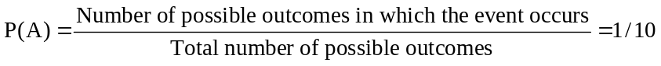

5.5 d/p/m You could check a large number of electric meters and find the proportion of times that the right-hand digit is a seven.

5.6 d/p/m When a die is rolled 60 times, 60 * 1/6 = 10 times the die should show a "2". If a "2" only comes up 9 times, that does not mean the die is "loaded". According to the law of large numbers, over a large number of trials, the relative frequency will approach the probability of its occurrence for a single trial. This does not mean that you will hit it exactly after 60 rolls.

5.7 d/p/m The information in text Table 5.1 would suggest that insurance premiums would decrease for men and increase for women. This would occur since women were probably paying lower rates than men before, because mortality rates are lower for females than for males.

5.8 c/p/m Let A = attended a sports event during the year. P(A) = 0.35 and the odds in favor of A occurring are: P(A) : 1 - P(A) => 0.35 : 0.65, or approximately 1: 2.

5.9 c/p/m If the odds in favor of an event happening are A:B, the probability is A/(A + B).
Since A = 4 and B = 7, the probability is 4/(4+7) = 4/11 = 0.36.

5.10 d/p/m
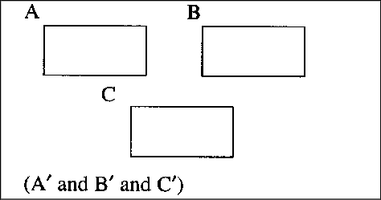

5.11 d/p/m
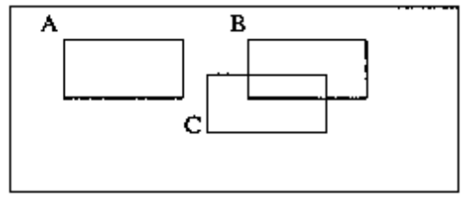

5.12 d/p/m
a. Having a BAC of 0% (event A, 265 persons) and having a BAC ≥ 0.10% (event C, 159 persons) are
mutually exclusive events; they cannot occur at the same time.
b. Having a blood alcohol level of 0% (event A) and being between 0 and 19 years old (event D) are two intersecting events. There are 142 fire fatalities in (A and D).

5.13 c/a/m
a. (A and A') contains zero victims. You can't have a blood alcohol level of 0% and have a blood alcohol level > 0% at the same time.
b. (C or F) contains 6 + 41 + 77 + 35 + 29 + 8 = 196 victims.
c. (A' and G') contains 7 + 8 + 8 + 6 + 41 + 77 = 147 victims.
d. (B or G') contains 454 - (47 + 35) = 372 victims since the 47 and the 35 are the only values not
contained in (B or G').

5.14 c/a/m P(G and C) = 35/454 = 0.077

5.15 d/p/m parts a, b, and c:
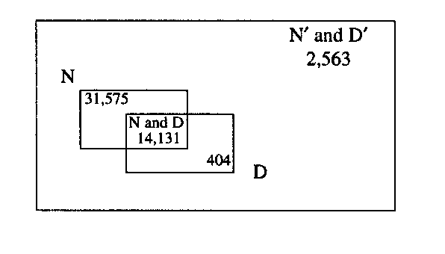
d. Region (N or D). There are 31,575 + 14,131 + 404 = 46,110 gas well completions in this region.
e. Region (N' or D'). There are 31,575 + 404 + 2,563 = 34,542 gas well completions in this region.

5.16 c/a/m a. P(N and D) = 14,131/48,673 = 0.290. b. P(N' and D') = 2563/48,673 = 0.053.

5.17 c/p/m Let F = Opening Franchise and R = Raising Speed limit. The two events F and R are not mutually exclusive.
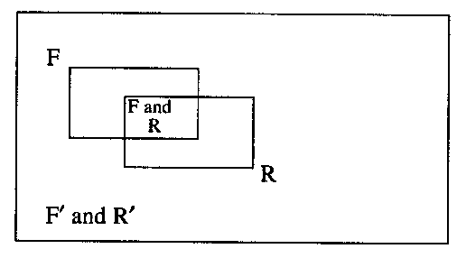

5.18 c/p/m Let S = Shopping mall developer wins bid , and let H = Historical Society wins bid.
Both events can not happen at the same time; they are mutually exclusive. The S rectangle in the Venn diagram will not overlap with the H rectangle. One must win the bid, so the Venn diagram will consist of only these two rectangles.

5.19 c/a/m P(South or Midwest or Yes) = (20.7 + 14.1 + 9.7 + 12.2)/60.0 = 0.945.
P(West and No) = 2.1/60.0 = 0.035.

5.20 c/a/m
 | M = Male | M’ = Female
S = Sports | 35 | 36 | 71
S’ = No Sports | 65 | 84 | 169
 | 100 | 120 | 240
The probability that the randomly selected graduate will be a male who is not a member of a sports team is 65/240 = 0.271.
The probability that the randomly selected graduate will be either a female or a member of a sports team is (120 + 35)/240 = 0.646.

5.21 c/a/m
 | A | B | C | D
Number Who Sign Up | x = 0 | x = 1 | x = 2 | x ≥ 3
Relative Frequency | 0.35 | 0.30 | 0.25 | 0.10
The probability that at least two people sign up is P(C or D) = P(C) + P(D) = 0.25 + 0.10 = 0.35.
The probability that no more than one person signs up is P(A or B) = P(A) + P(B) = 0.35 + 0.30 = 0.65.

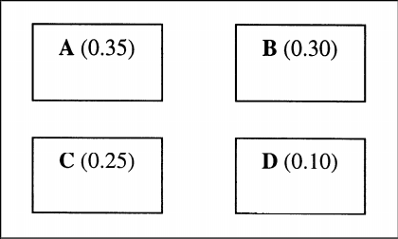

5.22 c/a/m The events A, B, C, D, E, and F are mutually exclusive.
a. P(C or D or E or F) = P(C) + P(D) + P(E) + P(F) = 0.16 + 0.09 + 0.07 + 0.05 = 0.37
b. P(B or C) = P(B) + P(C) = 0.25 + 0.16 = 0.41
c.
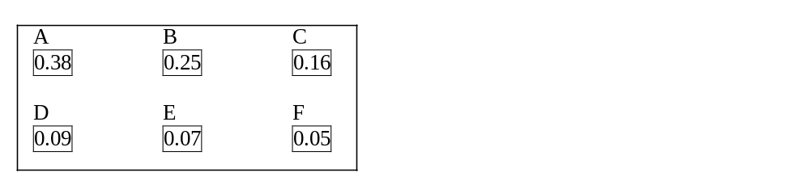
d. P(A or B or E) = P(A) + P(B) + P(E) = 0.38 + 0.25 + 0.07 = 0.70
P(A or F) = P(A) + P(F) = 0.38 + 0.05 = 0.43
P(A' or B) = P(A') = 1 - 0.38 = 0.62, Since the event B is contained in A'.
P(A or B or C') = P(C') = 1 - 0.16 = 0.84, since the events A and B are contained in C'.

5.23 c/a/m Let F = franchisees, C = company, and A = affiliates. Since A, C, and F are mutually exclusive events, P(F or A) = 21,328/31,967 + 4137/31,967 = 0.797.

5.24 c/p/m P(A or B or C) = 1.0
P(A) + P(B) + P(C) = 1.0 (since A, B, and C are mutually exclusive)
0.3 + 0.6 + P(C) = 1.0, solve for P(C), and P(C) = 0.1
Therefore, P(A or C) = P(A) + P(C) = 0.3 + 0.1 = 0.4.

5.25 c/a/m
a. Events A, B, C, D, and E are mutually exclusive, so their respective rectangles will not overlap.
b. P(A) = 0.13.
c. P(A or B) = 0.13 + 0.17 = 0.30.
d. P(A or D') = P(D') = 1 – 0.11 = 0.89, since A is contained in D'.

5.26 c/a/m
a. Events R, C, I, and G are mutually exclusive, so their respective rectangles will not overlap.
b. P(R) = 0.860
c. P(C or G) = 0.118 + 0.006 = 0.124
d. P(R or C') = P(C') = 1 – 0.118 = 0.882, since R is contained in C'.

5.27 c/a/m The frequencies are in thousands.
 | Life, Phys. | Farm, Fish. | Total
Male | 777 | 786 | 1563
Female | 588 | 204 | 792
Total | 1365 | 990 | 2355
 | Life, Phys. | Farm, Fish. | Total
Male | 0.33 | 0.33 | 0.66
Female | 0.25 | 0.09 | 0.34
Total | 0.58 | 0.42 | 1.000
P(Male or Life, Phys.) = 0.66 + 0.25 = 0.91

5.28 c/a/m
a. P(A or D) = P(A) + P(D) - P(A and D) = 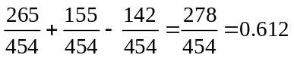

b. P(B or F) = P(B) + P(F) - P(B and F) = 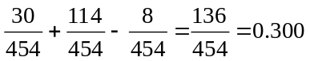

c. P(C or G) = P(C) + P(G) - P(C and G) = 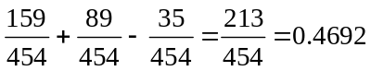

d. P(B or C or G) = P(B) + P(C) + P(G) - P(B and C) - P(B and G) - P(C and G)
+ P(B and C and G) = 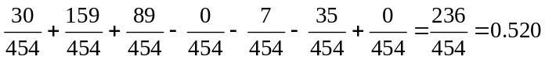

5.29 c/a/m
a. P(D or N) = P(D) + P(N) - P(D and N) = 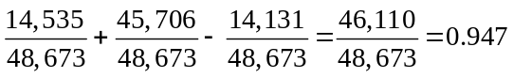

b. P(D' or N') = P(D') + P(N') - P(D' and N') = 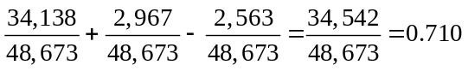

c. P(D or N') = P(D) + P(N') - P(D and N') = 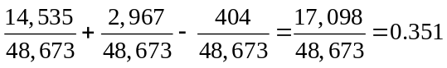

d. P(D' or N) = P(D') +P(N) - P(D' and N) = 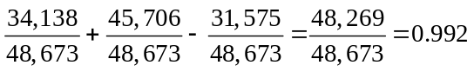

5.30 d/p/e A marginal probability is the probability that an event will occur regardless of any other events, while a joint probability is the probability that two or more events will all occur.

5.31 c/p/d It is possible for P(A) = 0.7, P(B) = 0.6, and P(A and B) = 0.35. See the Venn diagram below.
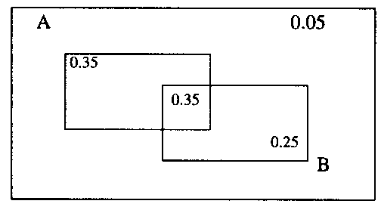
Events A and B cannot be mutually exclusive because if they were, then P(A or B) = P(A) + P(B)
= 0.7 + 0.6 = 1.3. However, this is impossible since probabilities cannot be greater than one.

Events A and B cannot be independent because if they were, then P(A and B) = P(A)*P(B) = 0.7*0.6
= 0.42. However, the exercise says that P(A and B) = 0.35, not 0.42.

5.32 d/p/m If events A and B are independent,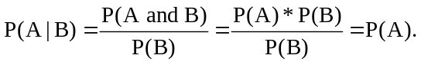
5.33 c/a/m Define the following events:
A = Renter household has a dishwasher.
B = Homeowner household has a dishwasher.
From the statement of the problem, we know P(A') = 0.57 and P(B') = 0.28.
Therefore, P(A) = 1 - 0.57 = 0.43 and P(B) = 1 - 0.28 = 0.72. Events A and B are independent.
a. P(A' and B') = P(A')*P(B') = (0.57)(0.28) = 0.16
b. P(A and B) = P(A)*P(B) = (0.43)(0.72) = 0.31
c. P(A and B') = P(A)*P(B') = (0.43)(0.28) = 0.12
d. P(B and A') = P(B)*P(A') = (0.72)(0.57) = 0.41

5.34 c/a/e Define the following events: H = Heads is tossed; T = Tails is tossed. Since heads and tails are equally likely, P(H) = 0.5 and P(T) = 0.5. Consecutive tosses of a coin are independent events since what occurs one time would not affect the next outcome.
P(HTH) = P(H)*P(T)*P(H) = 0.5*0.5*0.5 = 0.125

5.35 c/a/m Define the following event: A_{i} = part i lasts through the warranty period.
Since the parts operate independently, P(appliance works satisfactorily throughout warranty)
= P(A₁ and A₂ and A₃ and ... and A₁₆) = P(A₁)*P(A₂)*P(A₃)* ... *P(A₁₆) = (0.99)¹⁶ = 0.851.

5.36 c/a/m Define the following event: A_{i} = i^{th} patient chosen requires bifocal lenses.
From the statement of the problem, we know P(A_{i}) = 0.5. The tree diagram is shown below.
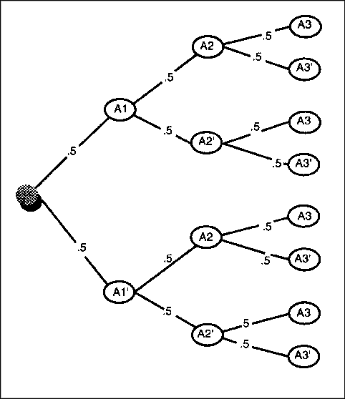
a. P(A₁A₂A₃) = P(A₁)*P(A₂)*P(A₃) = 0.5*0.5*0.5 = 0.125
P(A₁'A₂'A₃') = P(A₁')*P(A₂')*P(A₃') = 0.5*0.5*0.5 = 0.125
b. The probabilities found in part (a) would probably not be accurate if the 3 people were selected
from retirees over age 65. The probabilities given might not be accurate for this group.

5.37 c/a/d Define the following events:
A₁ = first individual's tax return prepared by H & R Block, A₂ = second individual's tax return prepared by H & R Block. From the statement of the problem, we know P(A₁) = 0.158,
P(A₂) = 0.158, and A₁ and A₂ are independent events.
a. P(A_{l} and A₂) = P(A₁)*P(A₂) = 0.158*0.158 = 0.025
b. P(A₁' and A₂') = P(A₁')*P(A₂') = 0.842*0.842 = 0.709
c. P(A₁ and A₂') + P(A₁' and A₂)
= P(A₁)*P(A₂') + P(A₁')*P(A₂) = 0.158*0.842 + 0.842*0.158 = 0.266

5.38 c/a/d From the statement of the problem, we know P(H) = 0.904 and P(C) = P(H and C) = 0.340.
a. P(H) = 0.904 b. P(C | H) = P(C and H)/P(H) = 0.340/0.904 = 0.376
c. P(H and C) = 0.340 d. P(H and C') = P(H)*P(C'| H) = 0.904*0.624 = 0.564

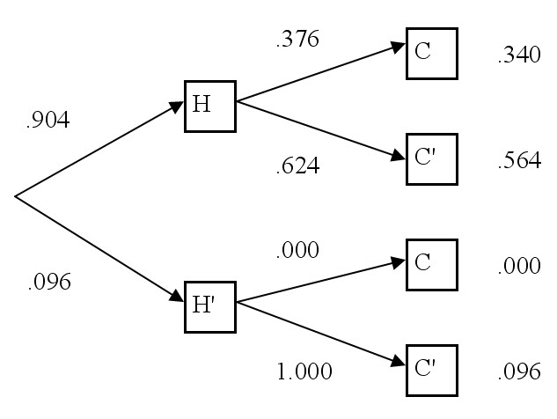

5.39 c/a/m Define the following events: A = takes cab A, B = takes cab B, S = stalls at the light.
From the statement of the problem, we know P(A) = 0.5, P(B) = 0.5, P(S | A) = 0.25,
and P(S | B) = 0.1. See the tree diagram below.
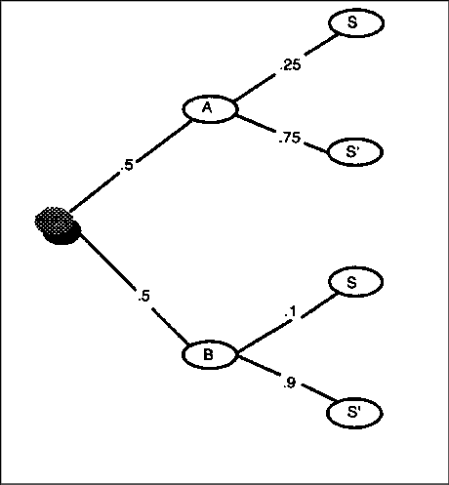
P(S) = P(A and S) + P(B and S) = P(A)*P(S | A) + P(B)*P(S | B) = 0.5*0.25 + 0.5*0.1 = 0.175

5.40 c/a/m
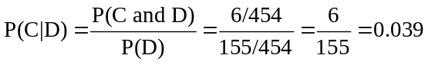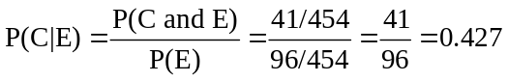

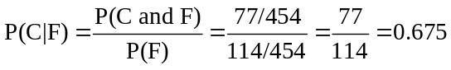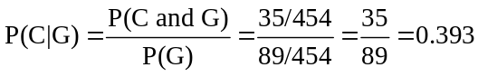

Age group F (ages 40 - 59) seem more likely to be intoxicated at the time they were victims.

5.41 c/a/m Given the fact that they are entering the restaurant, it is likely that they enjoy Wendy's food; i.e., they are probably not among the 40% who dislike Wendy's hamburgers. Also, because they are a couple, their tastes may be similar. The probability may be greater than 0.36.

5.42 c/a/m
 | M = Male | M’ = Female
S = Sports | 35 | 36 | 71
S’ = No Sports | 65 | 84 | 169
 | 100 | 120 | 240
If the student chosen is known to be on a sports team, the probability that the student is a female is
36/71 = 0.507.

5.43 c/a/m
 | A | B | C | D
Number Who Sign Up | x = 0 | x = 1 | x = 2 | x ≥ 3
Relative Frequency | 0.35 | 0.30 | 0.25 | 0.10
If the advisor has at least one person sign up for the advanced class, the probability that at least three people have signed up is 0.10/(0.30 + 0.25 + 0.10) = 0.10/0.65 = 0.154

5.44 c/a/m
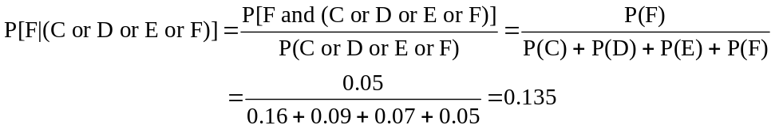

5.45 c/a/m
a. P(boy) = 0.51
b. With medical intervention, P(have a boy | wanted a boy) = 0.85.
c. With medical intervention, P(have a girl | wanted a girl) = 0.77.

5.46 c/a/d
a. Events: T = the couple is placed in the treatment group; T' = the couple is placed in the control group. Since the couple is randomly placed into either the treatment group or the control group, the prior probability for being in the treatment group is 0.5, P(T) = 0.5.

b. Events: G = the child is a girl; G' = the child is not a girl. The posterior probability we want to find is P(T | G). The tree diagram at the left, below, is the order in which things actually occurred. The tree diagram at the right is the "reversed" tree diagram.
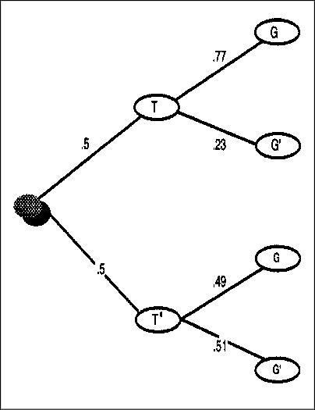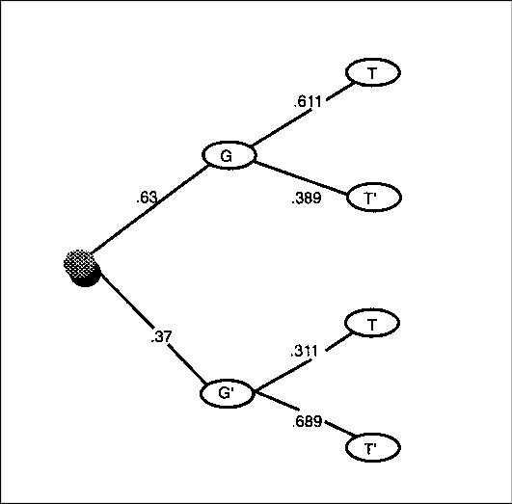
Using the "chronological" tree diagram at the left, we can determine the probabilities shown in the "reversed" tree diagram at the right.

P(G) = P(T and G) + P(T' and G) = 0.385 + 0.245 = 0.63

and 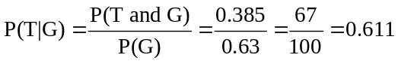

Using Bayes' Theorem:

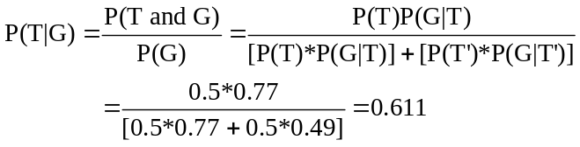

5.47 c/a/d
a. Events: F = fair coin, F' = unbalanced coin. Since we randomly select a coin, the prior probability of
selecting the fair coin is 0.5, P(F) = 0.5.
b. Events: H = coin lands heads, H' = coin lands tails. The posterior probability we want to find is
P(F | H). The tree diagram at the left, below, is the order in which things actually occurred.
The tree diagram at the right is the "reversed" tree diagram.

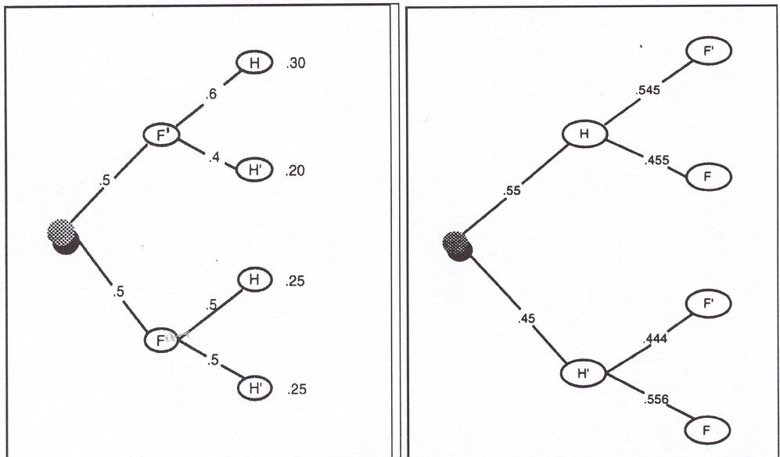

Using the "chronological" tree diagram at the left, we can determine the probabilities shown in the "reversed" tree diagram at the right.
P(H) = P(F' and H) + P(F and H) = 0.30 + 0.25 = 0.55 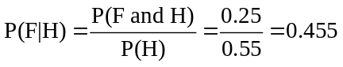
Using Bayes' Theorem:
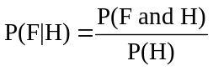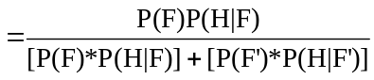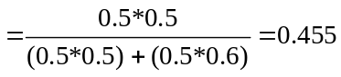

5.48 c/a/d Events: A = takes cab A and B = takes cab B. Since the driver randomly selects a cab, the prior probability of selecting cab A is 0.5, P(A) = 0.5.
Events: S = the cab stalls and S' = the cab does not stall. The posterior probability we want to find is
P(A | S). The tree diagram at the left, below, is the order in which things actually occurred. The tree diagram at the right is the "reversed" tree diagram.
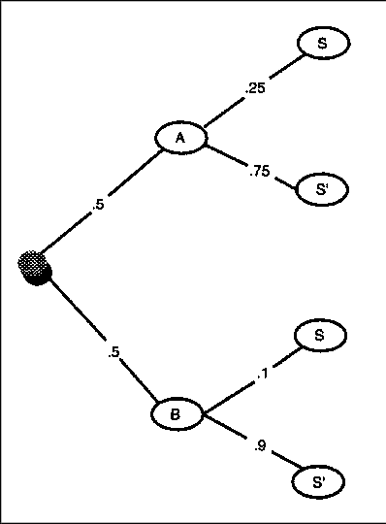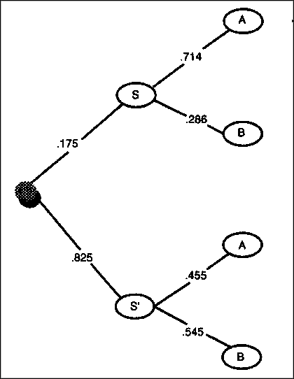

Using the "chronological" tree diagram at the left, we can determine the probabilities shown in the "reversed" tree diagram at the right.
P(S) = P(A and S) + P(B and S) = 0.125 + 0.050 = 0.175

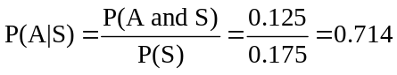

Using Bayes' Theorem:
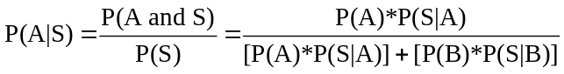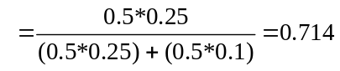

5.49 c/a/d
a. Events: A = item is from machine A, B = item is from machine B, and C = item is from machine C. The prior probability the item came from machine C is 0.1, P(C) = 0.1.
b. Events: D = the item is defective and D' = the item is not defective. The posterior probability we want
to find is P(C | D). The tree diagram in the order in which things actually occurred is given below:
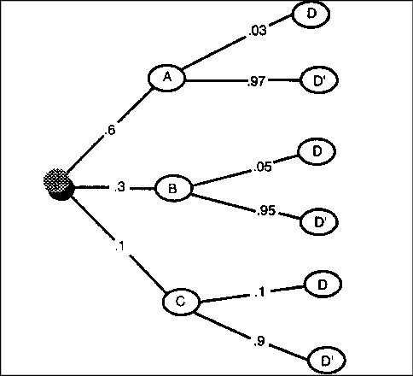
P(D) = P(A and D) + P(B and D) + P(C and D) = 0.018 + 0.015 + 0.010 = 0.043

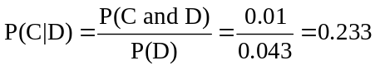

Using Bayes' Theorem:

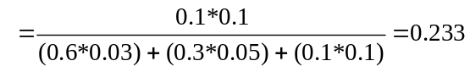

5.50 c/a/e The first deduction can be treated in n₁ = 3 ways, the second one in n₂ = 2 ways.
Using the principle of multiplication, there are n₁*n₂ = 3*2 = 6 ways of treating the two deductions.

5.51 c/a/m There are k = 8 independent events, each of which can occur in n = 2 different ways.
Using the principle of multiplication, the total number of possibilities is n^{k} = 2⁸ = 256.

5.52 c/a/m There are n = 10 people taken r = 2 at a time and the order does make a difference.
Therefore, the total number of different ways the trophies can be awarded is:
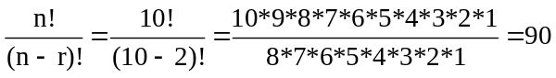

5.53 c/a/m There are 4 different specifications in the ad. The first specification has n₁ = 2 choices, the second has n₂ = 3 choices, the third has n₃ = 2 choices, and the fourth has n₄ = 3 choices. Using the principle of multiplication, there are n_{l}*n₂*n₃*n₄ = 2*3*2*3 = 36 different versions of the ad.

5.54 c/a/m There are n = 37 different possibilities that can be placed in each of the remaining k = 3 positions on the license plate. Using the principle of multiplication, his request can be satisfied in n^{k} = 37³ = 50,653 different ways.

5.55 d/a/m Permutations take order into account while combinations do not. Thus, the number of combinations will be less than the number of permutations, as there are r! permutations for every possible combination. The number of combinations is 1/r! as large as the number of permutations.

5.56 c/a/m The number of possible combinations of n = 12 clients that the counselor can see in r = 8 appointment times is:
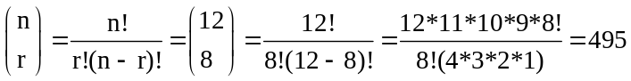

5.57 c/a/m The number of possible combinations of n = 6 workers that can fill r = 3 openings is:
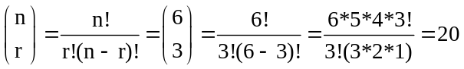

5.58 c/a/m Since the order of arrangement is important, we need to find the number of possible permutations of n = 25 exhibits taken r = 10 at a time for the display.

5.59 c/a/m Since order is important, we need to find the number of possible permutations of n = 35 customers taken r = 20 at a time.
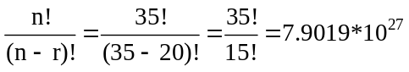

CHAPTER EXERCISES
5.60 c/a/m
a. The odds against something occurring are the reverse of the odds in favor. Since the odds in favor
are 1 to 240,000, the odds against are 240,000 to 1.
b. Event: S = struck by lightning. If the odds in favor of an event happening are A to B, the probability
of the event happening is A/(A + B).
Since A = 1 and B = 240,000, then 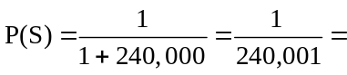0.00000417.
c. The probability of not getting struck by lightning in a given year is 1 - 0.00000417 =
0.99999583 = P(S'). In 20 independent years, the probability of not getting struck by lightning is 0.99999583²⁰. Therefore, the probability of getting struck at least one time during the next 20 years is 1 - 0.99999583²⁰ = 1 - 0.9999166 = 0.0000834.

5.61 c/a/m Define the following: A = win $1000 per week for life, and B = win a free hamburger.
a. If the odds in favor are A to B, then the probability is A/(A + B).
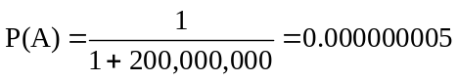
b. P(B) = 1/(1+15) = 0.0625
c. P(A or B) = P(A) + P(B) = 0.000000005 + 0.0625 = 0.062500005 (A and B are mutually exclusive
events.)
d. P(A and B) = 0 since these are mutually exclusive events. Sheila will receive only one coupon.

5.62 c/a/m Each time Sheila visits the franchise, whether she wins will be independent of what occurred the time before. Define the following event: B_{i} = win a free hamburger on the i^{th} visit. From Exercise 5.61, P(B) = 0.0625. Therefore, P(B_{i}') = 1 - P(B_{i}) = 1 - 0.0625 = 0.9375.
a. P(B₁' and B₂' and B₃' and B₄' and B₅') = P(B₁')*P(B₂')*P(B₃')*P(B₄')*P(B₅') = (0.9375)⁵ = 0.724.
b. P(B₁' and B₂' and … and B₁₀') = (0.9375)¹⁰ = 0.524
c. P(B₁' and B₂' and … and B₂₀') = (0.9375)²⁰ = 0.275
d. P(B₁' and B₂' and … and B₄₀') = (0.9375)⁴⁰ = 0.076

5.63 c/a/m
a. There are 1000 different numbers that all have an equal chance of occurring. Since Sam is buying
only one ticket, the probability he wins is 1/1000, or 0.001.
b. The probability found in part (a) is a classical probability since it represents the proportion of times that an event can be theoretically expected to occur.
c. The number drawn each day is independent of the number drawn on any other day. Therefore, the number drawn one day will have no effect on the probability of a number occurring the next day.

5.64 c/a/d Define the following events:
A = arrested for Homicide B = arrested for Assault C = arrested for Burglary
D = arrested for Arson E = arrested for Drug Offenses F = arrested for Weapons
G = arrested for Public Disorder H = Prosecuted I = Convicted
J = Jailed for > 1 year
Allen was arrested for burglary, Bill was arrested for a weapons offense, and Charlie was arrested on a public-disorder charge. The decisions regarding their fates are unrelated (independent).
a. P(C and J) = 0.28

b. P[(C and I) or (F and I)] = P(C and I) + P(F and I) - P[(C and I) and (F and I)]
= 0.81 + 0.70 - (0.81)(0.70) = 0.943

c. P[(C and J') and (F and J') and (G and J')] = P(C and J')*P(F and J')*P(G and J')
= (1 - 0.28)*(1 - 0.13)*(l - 0.12) = 0.551

d. P[(C and I) and (F and I) and (G and I')] = P(C and I)*P(F and I)*P(G and I')
= 0.81*0.70*(l - 0.85) = 0.08505

e. P[(C and H') and (F and H') and (G and H')] = P(C and H')*P(F and H')*P(G and H')
= (1 - 0.88)*(l - 0.83)*(1 - 0.92) = 0.001632

5.65 c/a/d
a. The number of possible combinations of n = 3 with r = 1 person convicted is
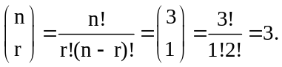
b. The number of possible combinations of n = 3 with r = 2 people convicted is
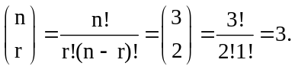
c. The number of possible combinations of n = 3 with r = 3 people convicted is
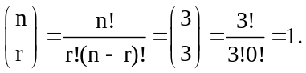

5.66 c/a/d
a. 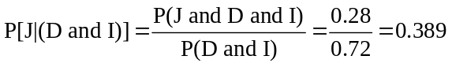

b. 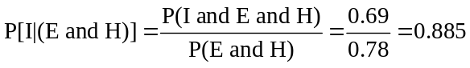

c. 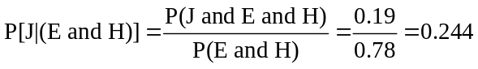

5.67 c/a/d Define the following events: A = system A is "down" and B = system B is "down".
From the statement of the problem, we know P(A) = 0.1 and P(B) = 0.05. A and B are independent events.
a. P(A and B) = P(A)*P(B) = (0.1)(0.05) = 0.005

b. P(A' and B') = P(A')*P(B') = (1 - 0.1)(1 - 0.05) = 0.855

c. P(A and B') + P(A' and B) = P(A)*P(B') + P(A')*P(B) = (0.1)*(1 - 0.05) + (1 - 0.1)(0.05) = 0.14

d. P(A' or B') = P(A') + P(B') - P(A' and B') = 0.90 + 0.95 - 0.855 = 0.995

5.68 c/a/m Define these events: A = the upper attachment hook fails; B = the lower hook fails.
From the statement of the problem, we know P(A) = 0.2 and P(B) = 0.1. A and B are independent events. The hoisting job will be successful if both hooks do not fail.
P(A' and B') = P(A')*P(B') = (1 - 0.2)(1 - 0.1) = 0.72

5.69 c/a/m Define these events: A = less than $20,000 B = $20,000 - under $40,000
C = $40,000 - under $60,000 D = $60,000 - under $80,000 E = $80,000 or more

a. P(A or B or C or D) = P(A) + P(B) + P(C) + P(D) = 0.1 + 0.2 + 0.3 + 0.25 = 0.85

b. 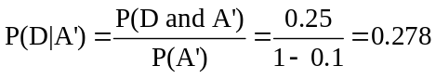

c. For each household:
Since the 2 households are independent, the probability that this occurs for both households is (0.214)² = 0.046.

5.70 c/a/m Define these events:
A = BAC is 0.00%, B = BAC is between 0.01% and 0.07%, C = BAC ≥ 0.08%

a. P(B or C) = P(B) + P(C) = 0.058 + 0.355 = 0.413

b. 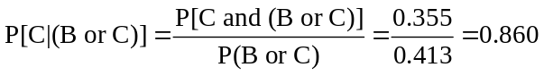

5.71 c/a/m
a. P(drilled in U.S.) = 7/10, or 0.7
b. P(drilled in U.S. or dry) = P(drilled in U.S.) + P(dry) - P(drilled in U.S. and dry)
= 7/10 + 7/10 – 5/10 = 9/10 = 0.9
c. P(dry | drilled in Nigeria) = P(dry and drilled Nigeria)/P(drilled Nigeria) = (2/10)/(3/10) = 0.667

5.72 c/a/m Each vehicle has a probability of 0.99999 of making it through the year without a major accident. If the vehicles are independent, the probability that the entire fleet will avoid a major accident during the year is (0.99999)^{200,000} = 0.135.

5.73 c/a/m The probability that any individual vehicle will be stolen is 1/184, so the probability that any individual vehicle will not be stolen is 183/184. If we randomly select 5 vehicles, whether one is stolen is independent of the other vehicles being stolen.
a. P(none of the vehicles is stolen) = (183/184)⁵ = 0.973
b. P(all the vehicles are stolen) = (1/184)⁵ = 4.741*10⁻¹²
c. Number of combinations of n = 5 vehicles with r = 2 stolen: 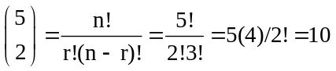

5.74 c/a/d Events: A = participant has had training in CPR; B = stricken patron survives.
a. From the statement of the problem, we know P(A) = 0.2, P(B | A) = 0.9, and P(B | A') = 0.4.
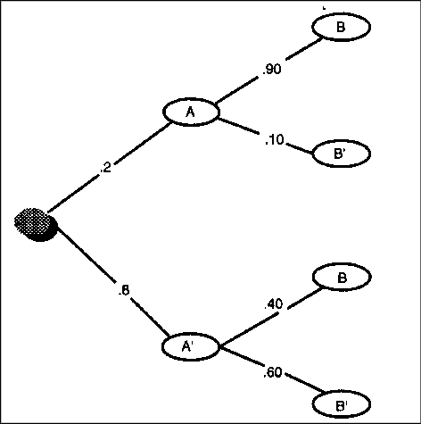
P(B) = P(A and B) + P(A' and B) = P(A)*P(B | A) + P(A')*P(B | A') = 0.2*0.9 + 0.8*0.4 = 0.5
b. The posterior probability we want to find is P(A | B). Using the information in part (a):
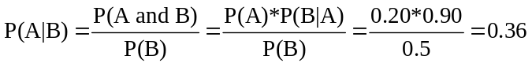
c. The posterior probability we want to find is P(A | B'). Using the information in part (a):
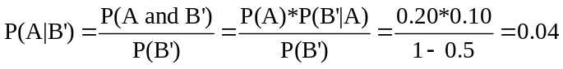

5.75 c/a/d P(adult has had CPR training) = 0.10; P(adult has not had CPR training) = 1 - 0.10 = 0.90.
For n independent adults, P(all of them have not had CPR) = 0.9^{n}. Therefore, P(at least one has had CPR) = 1 - 0.9^{n}. Find n so that 1 – 0.9^{n} ≥ 0.90 => 0.9^{n} < 0.10.
When n = 22, then 0.9^{n} = 0.0985, which is < 0.10.

5.76 c/a/m
Given A = take guided tour, B = make request for additional information, and C = make an offer:
P(C | A) = P(B | A) * P(C | B) = 0.20 * 0.02 = 0.004. We hope the realtor has other income sources.

5.77 c/a/m The probability that all three individuals would have a Sears appliance is (2/3)³ = 0.296.
Since the probability that none of the individuals would have a Sears appliance is (1/3)³ = 0.037, the probability that at least one of them will have a Sears appliance is 1 - 0.037 = 0.963.

5.78 c/a/m The chronological-order tree diagram for this situation is shown below:
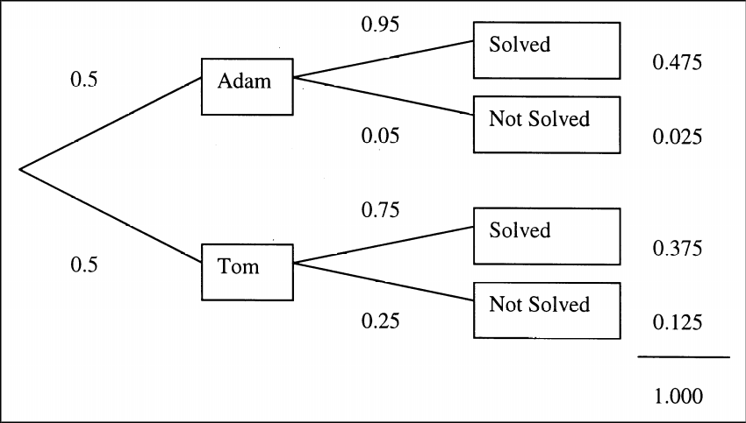
If a technical problem has just been received, it will be randomly assigned, so the probability that Adam will handle the problem is P(Adam) = 0.50. Given that the problem was solved, we can refer to the joint probabilities at the right side of the tree diagram to determine the probability that it had been assigned to Adam. This result will be P(Adam | Solved) = 0.475/(0.475 + 0.375) = 0.559.

5.79 c/a/d Define the following events: A = machine is in adjustment, D = unit is defective.
a. P(A) = 0.9
b. The posterior probability we want to find is P(A | D). The chronological (left) and reversed tree diagrams are shown below.
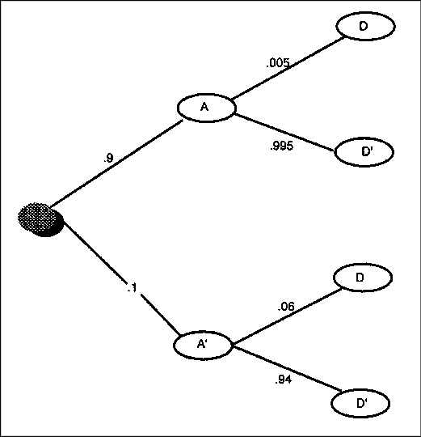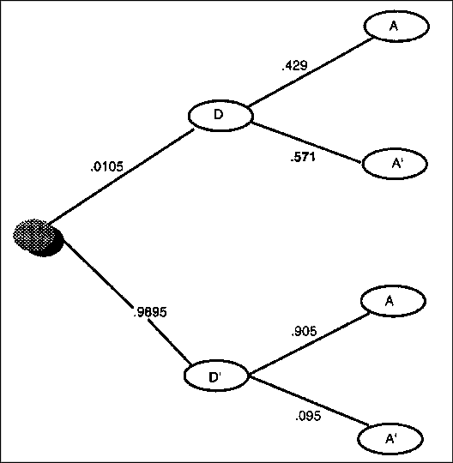
P(D) = P(A and D) + P(A' and D) = 0.0045 + 0.0060 = 0.0105

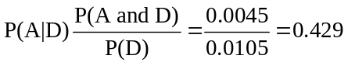

Using Bayes' Theorem:

5.80 c/a/d Define these events: A = borrower has been employed at present job ≥ 3 years,
B = borrower is behind in payments.
From the statement of the problem, we know P(A) = 0.8, P(B | A') = 0.15, and P(B | A) = 0.05.
The chronological (left) and reversed (right) tree diagrams are shown below.
a. P(A and B) = P(A)P(B | A) = 0.8*0.05 = 0.04
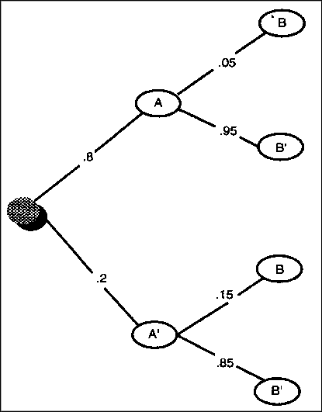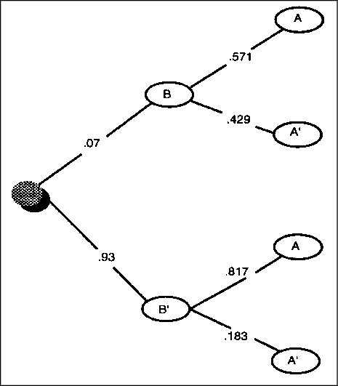

b. P(A' or B) = P(A') + P(B) - P(A' and B) = P(A') + P(A and B) + P(A' and B) - P(A' and B)
= P(A') + P(A and B) = (1 - 0.8) + 0.04 = 0.24
c. The posterior probability we want is P(A'| B). Using the tree diagrams,
P(B) = P(A and B) + P(A' and B) = P(A)*P(B | A) + P(A')*P(B | A')
= (0.8*0.05) + (0.2*0.15) = 0.07, and

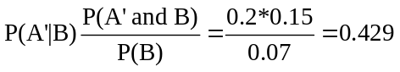

Using Bayes' Theorem:

5.81 c/a/m The number of possible combinations of n = 10 officers taken r = 3 at a time, disregarding their order, is:
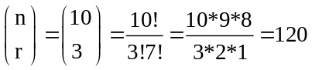

5.82 c/a/m Since order is not important, the number of possible combinations of n = 15 persons taken
r = 5 at a time is:
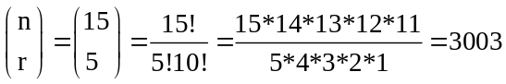

5.83 c/a/m Since order is important, the number of possible permutations of n = 12 faculty members
to teach r = 3 courses is:
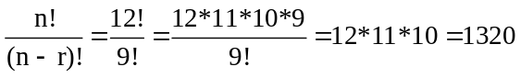

5.84 c/a/m
a. Since order is not important, the number of possible combinations of n = 6 soft drinks taken r = 3 at a time is:
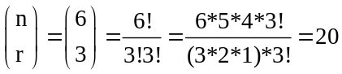

b. Since order is important, the number of possible permutations of n = 6 soft drinks taken r = 3 at a time is:
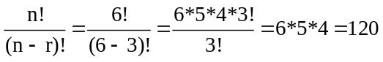

5.85 c/a/m There are n = 10 integers to choose from (0 through 9) for the k = 4 digit sequence. Using the principle of multiplication, the number of different possibilities for a lock combination is
n^{k} = 10⁴ = 10,000.

INTEGRATED CASES

THORNDIKE SPORTS EQUIPMENT
When Ted goes through the broken racquets downstairs, he should classify each racquet by the year it was produced and the company that supplied the material. This would give him a contingency table containing all the information about the broken racquets.

Then, using the relative frequency approach, Ted could find the probability that a broken racquet was produced in each of the past 6 years that the broken racquets have been saved. This would give Ted an idea as to whether there really have been more complaints since the company added a third supplier.
He could also take the racquets that were produced in the last year and a half, and find the probability that a broken racquet was made from materials received from each of the three suppliers. Then he could compare these three values to see if there really are more broken racquets that are made from the materials obtained from the third supplier. If so, Ted should strongly consider dropping the third supplier and just using the original two suppliers.

SPRINGDALE SHOPPING SURVEY
1. One-way tabulations using Minitab and the Springdale Shopping Survey database, SHOPPING:

Tally for Discrete Variables: SPRSPEND, DOWSPEND, WESSPEND

SPRSPEND Count DOWSPEND Count WESSPEND Count
2 1 3 1 3 2
3 1 4 5 4 8
4 25 5 21 5 19
5 25 6 41 6 32
6 44 7 82 7 89
7 54 N= 150 N= 150
N= 150

a. P(spends at least $15 at Springdale Mall) = 1.00 - P(spends less than $15)
= 1.00 - P(a response of 7) = 1.000 - 0.360 = 0.640
b. P(spends at least $15 at Downtown) = 1.00 - P(spends less than $15)
= 1.00 - P(a response of 7) = 1.000 - 0.547 = 0.453

c. P(spends at least $15 at West Mall) = 1.00 - P(spends less than $15)
= 1.00 - P(a response of 7) = 1.000 - 0.593 = 0.407
Comparing the preceding probabilities, Springdale Mall seems to be the strongest in terms of the amount of money a shopper spends during a typical shopping visit. West Mall seems weakest.

Tally for Discrete Variables: BSTQUALI

BSTQUALI Count
1 93
2 43
3 6
4 8
N= 150

d. P(feels Springdale Mall has highest quality) = P(a response of 1) = 93/150 = 0.620
e. P(feels Downtown has highest quality) = P(a response of 2) = 43/150 = 0.287
f. P(feels West Mall has highest quality) = P(a response of 3) = 6/150 = 0.040
Springdale Mall is the strongest in terms of quality of goods and West Mall is the weakest.

2. Two-way tabulations.
a. Variables 4 and 26.

Tabulated Statistics: SPRSPEND, RESPGEND

Rows: SPRSPEND Columns: RESPGEND
1 2 All

2 1 0 1
3 0 1 1
4 9 16 25
5 5 20 25
6 13 31 44
7 30 24 54
All 58 92 150

Cell Contents --
Count

Given that the respondent is a female, the probability is 0.739 that she will spend at least $15 during a visit to Springdale Mall.
A male is less likely than a female to spend at least $15 during a visit to Springdale Mall.

b. Variables 5 and 26

Tabulated Statistics: DOWSPEND, RESPGEND

Rows: DOWSPEND Columns: RESPGEND
1 2 All

3 0 1 1
4 2 3 5
5 9 12 21
6 15 26 41
7 32 50 82
All 58 92 150

Cell Contents --
Count

Given that the respondent is a female, the probability is 0.457 that she will spend at least $15 during a visit to Downtown.
A male is slightly less likely than a female to spend at least $15 during a visit to Downtown.

c. Variables 6 and 26.

Tabulated Statistics: WESSPEND, RESPGEND

Rows: WESSPEND Columns: RESPGEND
1 2 All

3 0 2 2
4 2 6 8
5 4 15 19
6 10 22 32
7 42 47 89
All 58 92 150

Cell Contents --
Count

Given that the respondent is a female, the probability is 0.489 that she will spend at least $15 during a visit to West Mall.
A male is less likely than a female to spend at least $15 during a visit to West Mall.

Based on the preceding probabilities, females are most likely to spend $15 or more at Springdale Mall and least likely to spend $15 or more Downtown.

Based on the preceding probabilities, males are most likely to spend $15 or more at Springdale Mall and least likely to spend $15 or more at West Mall. For all of the shopping areas, a male is less likely than a female to spend at least $15 during a visit to the area.

BUSINESS CASE

BALDWIN COMPUTER SALES (B)
In the Baldwin Computer Sales case, visited earlier in chapter 3, one of the areas of concern regarding the student purchase program was whether the probability of defaulting on the computer loan repayments might be related to the university attended by the student. Referring to the contingency table of frequencies below, we see that 137 out of 342 participating students did not repay their computer loan,
a default rate of 40.06%.

Tabulated statistics: Default, School

Rows: Default Columns: School

1 2 3 4 5 All

0 35 52 62 35 21 205
17.07 25.37 30.24 17.07 10.24 100.00
52.24 61.18 59.62 67.31 61.76 59.94

1 32 33 42 17 13 137
23.36 24.09 30.66 12.41 9.49 100.00
47.76 38.82 40.38 32.69 38.24 40.06

All 67 85 104 52 34 342
19.59 24.85 30.41 15.20 9.94 100.00
100.00 100.00 100.00 100.00 100.00 100.00

Cell Contents: Count
% of Row
% of Column

1. Of the 67 students in the program who attended university number 1, 32 of them defaulted. Given that a participant attended university 1, the conditional probability that he or she defaulted is 32/67 = 0.4776, expressed in the printout above as 47.76%.

2. Repeating the preceding for each of the other four universities, the conditional probabilities for defaulting on repayment can be determined from the printout and, along, with the conditional probability for university number 1, are as shown below. It appears that participants from university number 1 are most likely to default (47.76% default rate) and that participants from university number 4 are least likely to default (32.69% default rate).
(1) 32/67 = 0.4776 (2) 33/85 = 0.3882 (3) 42/104 = 0.4038
(4) 17/52 = 0.3269 (5) 13/34 = 0.3824

3. Of the 137 participants who defaulted, 32 were from the university with the highest default rate (university number 1). Thus, if a student is randomly chosen from those who have defaulted on their computer loan, the probability that they are from university number 1 can be calculated as 32/137,
or 0.2336.

